State of Washington
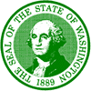
Department of Fish and Wildlife
2108 Grand Blvd. Vancouver WA 98661 (360) 696-6211

To: U.S. Army Corps of Engineers, Bonneville Dam Fisheries; FPOM

From: Washington Dept. of Fish and Wildlife, Ann Stephenson, Eric Kinne

Subject: 2013 AFF fish tank location and transfer of fish

Date: June 10, 2013

In 2013, three researchers will be using the Bonneville Adult Fish Facility (AFF) during the same time frame from mid-August through October: the Washington Dept. of Fish and Wildlife (WDFW), the Columbia River Intertribal Fisheries Commission (CRITFC) and the University of Idaho (U of I).

The U of I will be tagging steelhead during this time frame and WDFW will be tagging fall Chinook (both Tules and upriver Brights), coho and steelhead. Both groups can use the same transport tanks at the same time to relocate fish downstream since the release point(s) are the same. WDFW can provide an additional fish tank so there would be no delay in the transfer of fish downstream back into the river.

CRITFC’s activities occur at the east end of the AFF so they have no current overlapping need for space with the other researchers. The U of I is currently set up on the north-east end of the facility. In 2011 and 2012, the WDFW worked up fish in the small anesthetic tank off of an additional side flume which also exits towards the north-east end of the building. WDFW plans to use this flume again in 2013, starting August 12. With limited space for equipment and personnel in 2013, WDFW, with the U of I, propose moving the fish transport tank from the floor of the AFF up one level, onto the concrete slab above, parallel to the large exit doors. The tank, with water and fish weighs approximately 4800 pounds. The project’s structural crew has determined that is it sound to locate the tank at this location, plus there is adequate egress space for people to pass on the walkway with the tank there. Moving the transport tank to this location would allow adequate space for all groups to work up fish on the main floor of the AFF. Also, at this location, the tank is never suspended over the researchers, reducing the amount of risk to personnel.

The U of I experimented with the tank in the upper level at the end of May. (See Figure 1. The tank location is where the beam with the hardhat is.) They used a “sanctuary net bag” to transfer the fish from their anesthetic tank into the transport tank. Fish would be moved from both agencies anesthetic tanks into the transport tank with the use of such a fish tube or bag. U of I will also be experimenting with moving the fish from the anesthetic tank to the transport tank with the bag on a pulley, attached to the beam on the crane, to move the fish efficiently from one tank to the other (Figure 2). Minimal time is required to move the fish from one tank to the other using this method when the tank is located above the main floor.

WDFW and U of I request that this be forwarded to the Fish Passage Operation and Maintenance Team for approval at the June 2013 meeting.

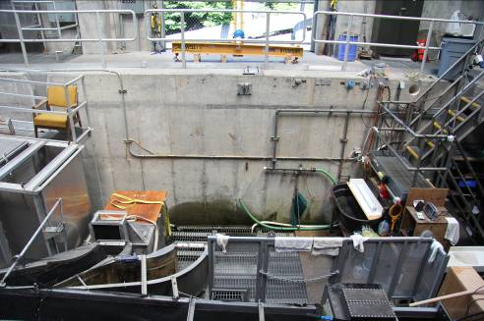
Figure 1. Bonneville Dam Adult Fish Facility

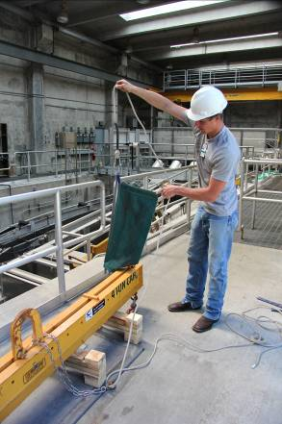
Figure 2. Fish net attached to pulley on beam.

